Up to now we had only worked with local repository on the local machine, all the codes had been committed in your local workstation. But if there are more developers working on one project storing code in their own local workstations won’t be much useful.

So, to solve the problem everyone needs to be stored the code to push to a central repository. Here Github is the centralized repository to store the code.

Github is a centralized repository which is maintaining on cloud which is host the repositories publicly. In order to login to Github use the below URL <https://github.com>

If you have an account already configured, login with your credentials, if not create your own credentials and login into Github.



Here, already I am having account created previously, so I signed with my credentials.

Once logged in, here is first page which are showing already existing repositories on my Github.

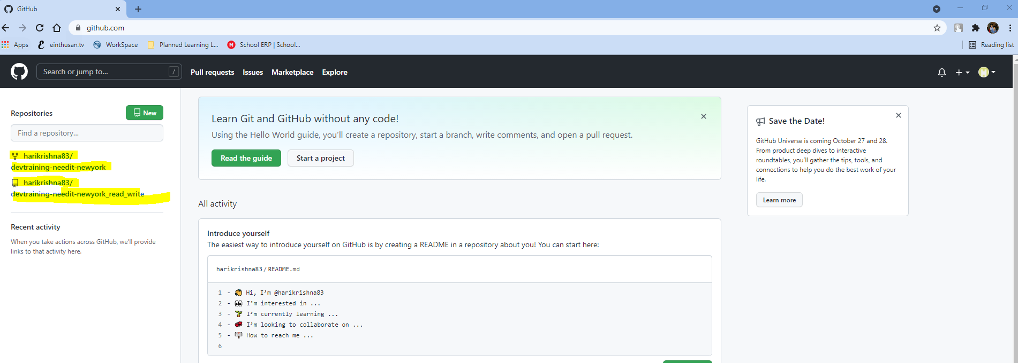

In order to create a new repository, click on ‘+’ sign which is showing at top right corner and click on “New Repository”.

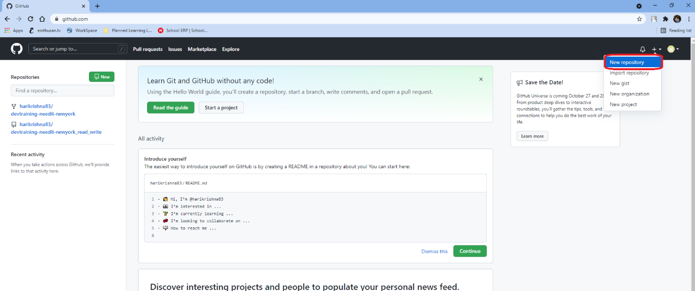

Provide all the Inputs as shown below and click on “Create repository”, to create a centralized repository on Github.com.

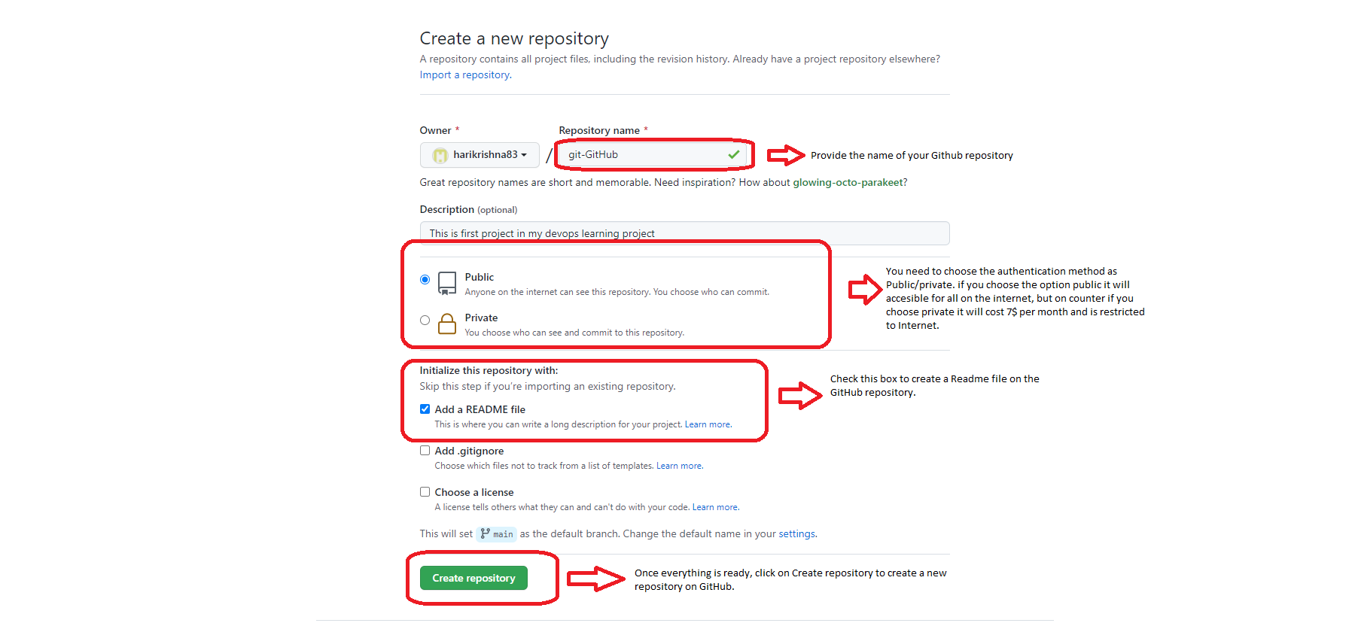

Below is the screenshot with the newly create repository with the initial Readme file.

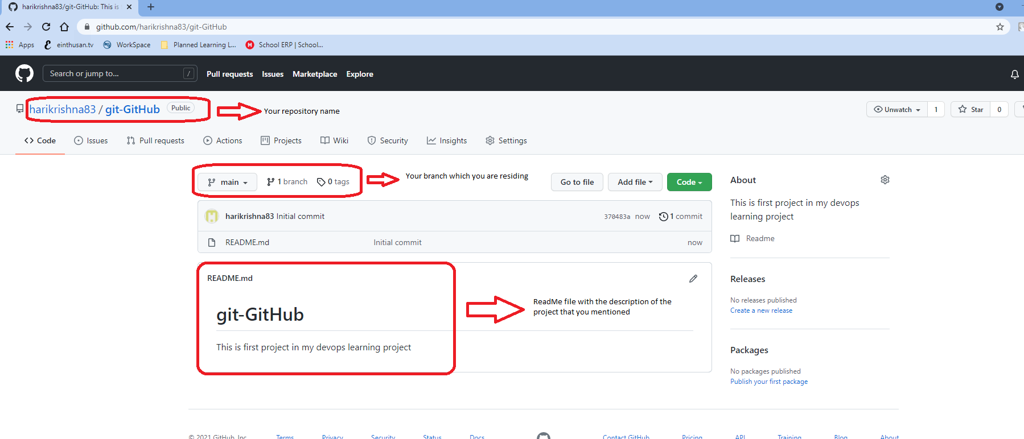

Now we had create a centralized repository. In order the pull all the code from centralized repository to your local repository, you need to go to your local machine and create a same different folder and issue the command as shown below.

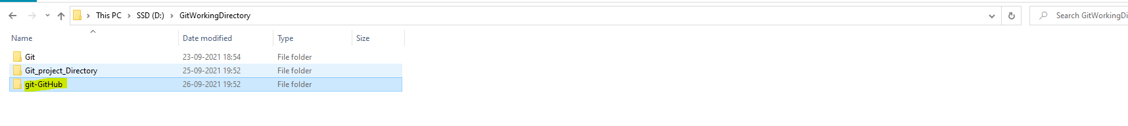

Now go to that new directory and initialize a Gitbash from there.

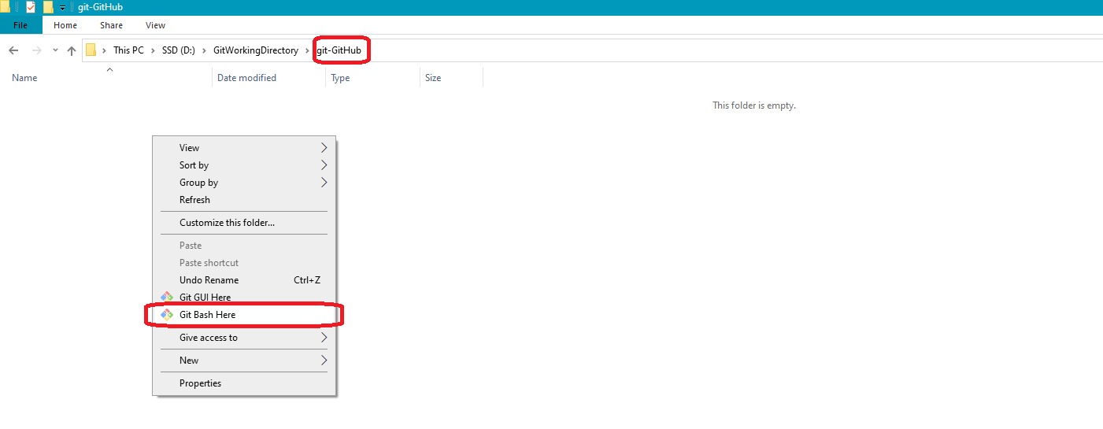

Once you launch the Git bash, you need to initialize the local repository with the command “git init”.

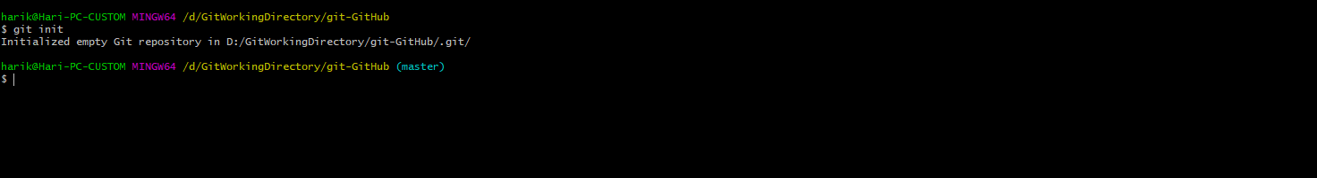

Now I need to sync the GitHub repository with the local repository, in order to do that issue first you need to configure the origin of the gitHub repository to your local repository.

First the remote Github repository URL as shown below.

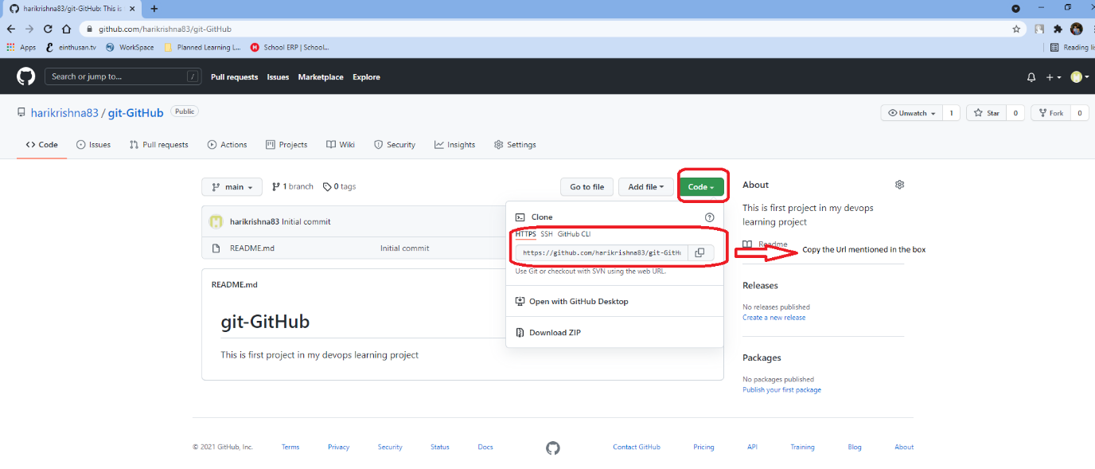

Now issue the following command as shown below.

# git remote add origin “https://github.com/harikrishna83/git-GitHub.git”

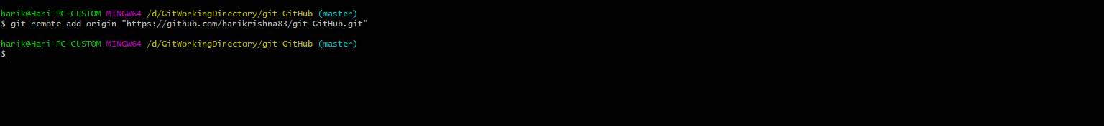

Now your local repository is been successfully linked with the centralized repository.

In order to sync the GitHub repository with the local repository, we need to initiate a pull request, in order to fetch the changes from centralized repository.

# git pull

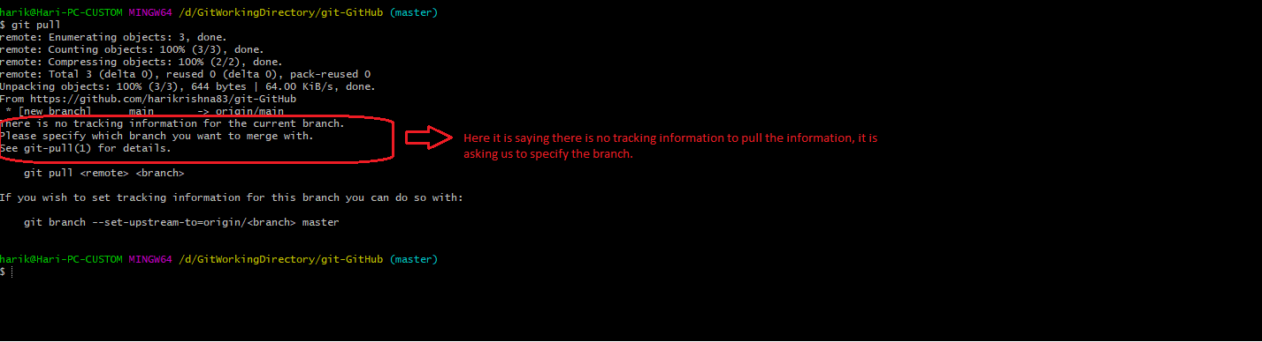

Here in the above command it is showing, there is no tracking information to pull and asking to mention the branch pull. So we need to mentioned branch name after the pull command.

Here we have one problem, if you create a repository on local by default it create a repository “master”, but on centralized Github repository by default it created a default branch “main”.

So while pulling the information from centralized repository to local, it will throw an error.



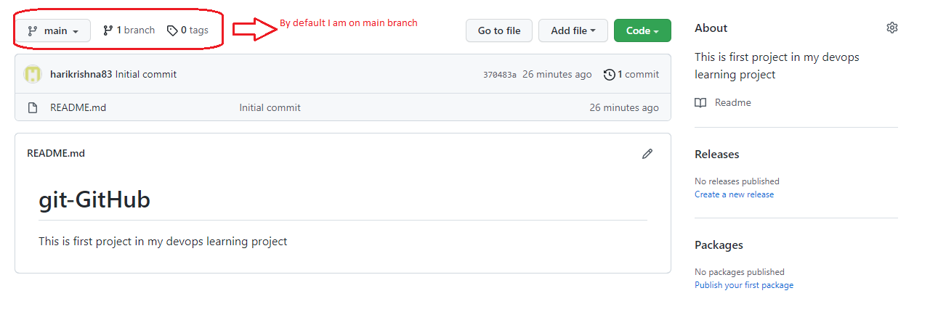

So if I issue the command as shown below, it will thrown an error as master branch doesn’t exists on centralized repository.

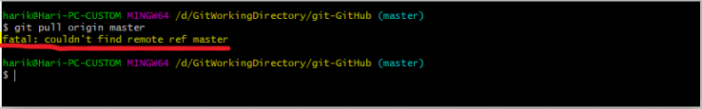

In order to rectify this error go to your centralized repository, and create a branch called “master” or create an branch “main” on your local repository. As of now I am creating a new branch “master” on GitHub.

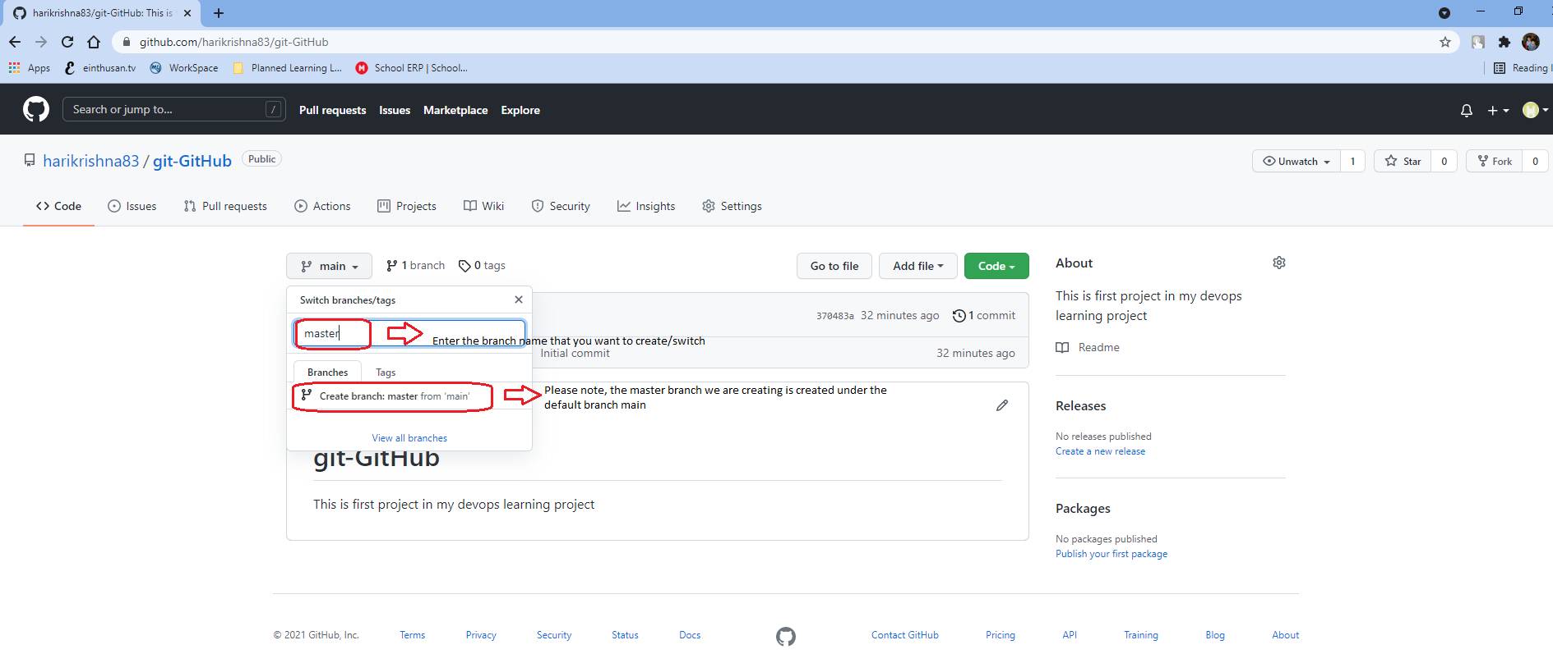

Here enter the branch name on the search field of Switch branches/tags and click on “create branch:” link to create the branch.

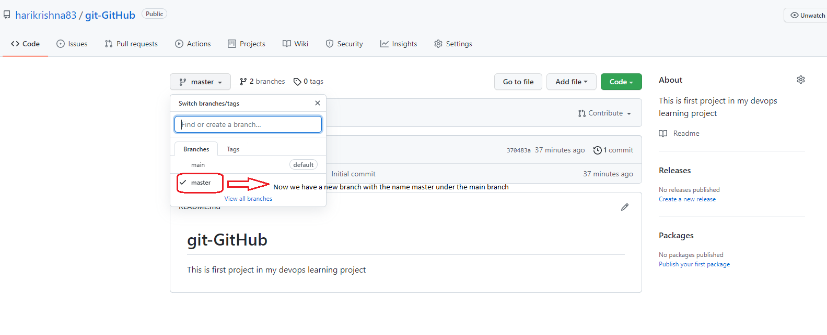

Now issue the command to “git pull” by specifying the origin as master.

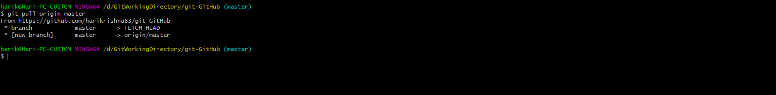

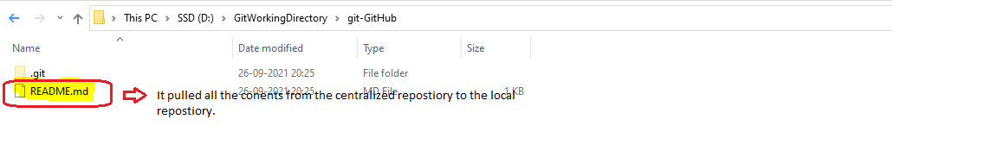

Now we will create a new file on local repository and push the code to centralized repository.

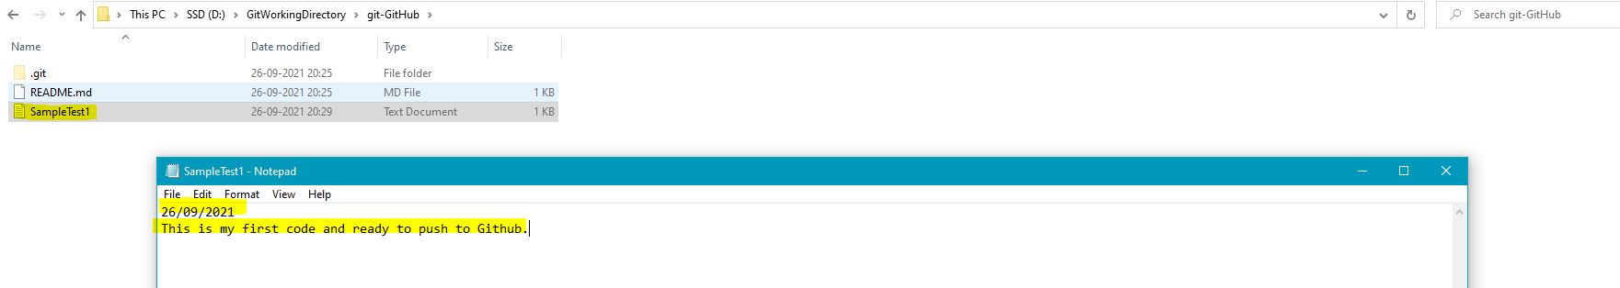

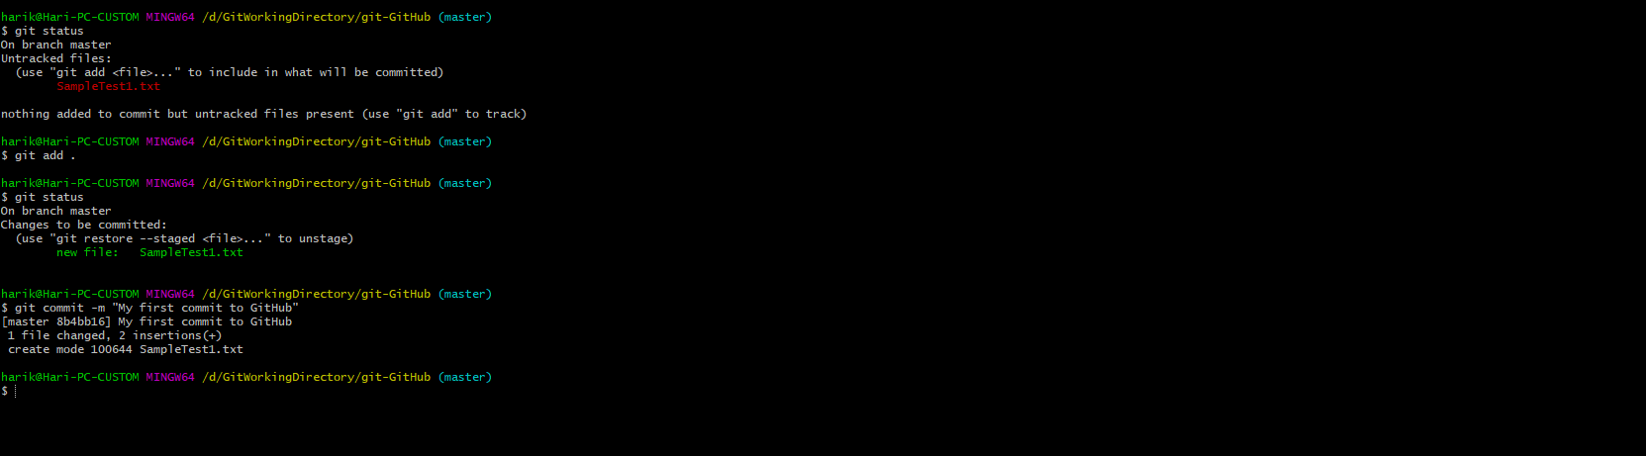

Now I need to push this local modified to centralized repository, in order to make available for all the other members.

As of now you can see on centralized repository, the newely create file “SampleText.txt” is not available.

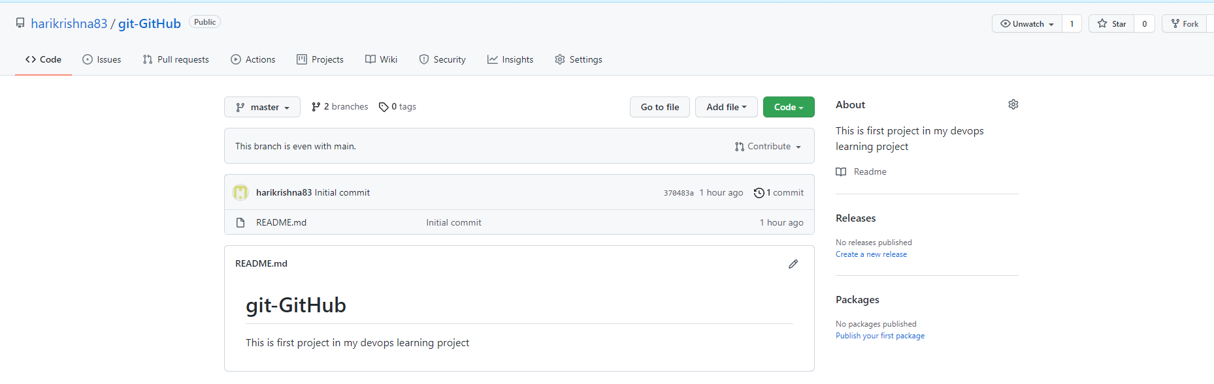

Now issue the command “git push” in order to push your changes from local to centralized repository.

# git push origin master

It will ask you for the GitHub credentials, you need provide the username and password, and once it is done it will push the local changes to centralized repository to the branch master.

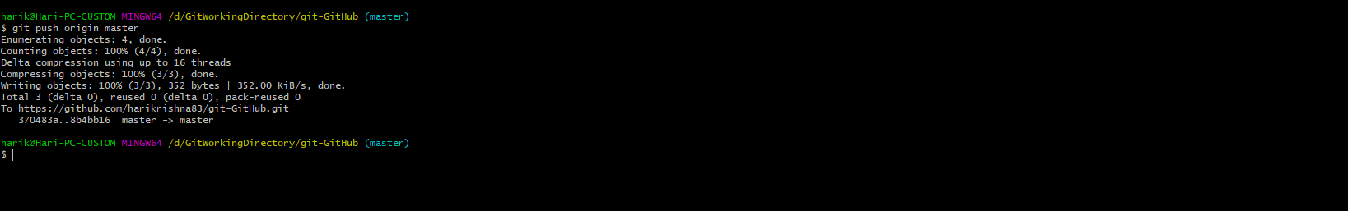

Now refresh the browser, you can see the new file

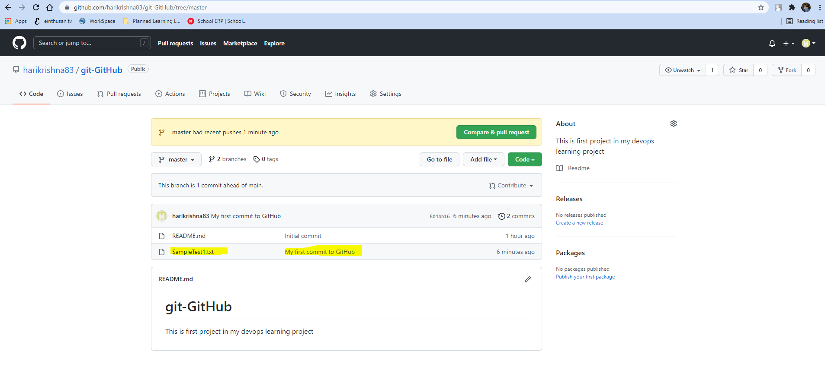

Click on the comment of your new file, it will show the commit id which is same as your local commit id.

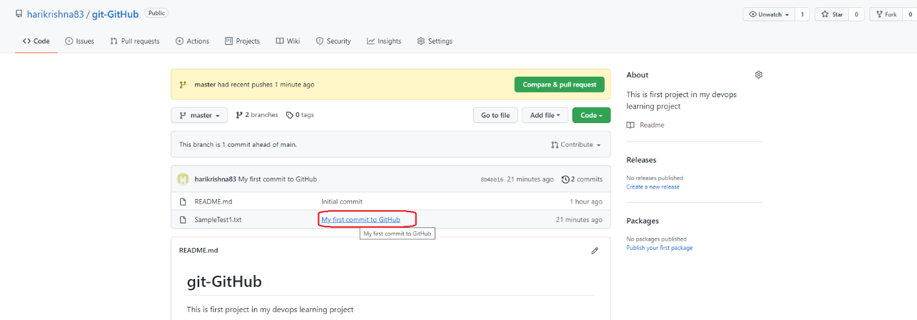

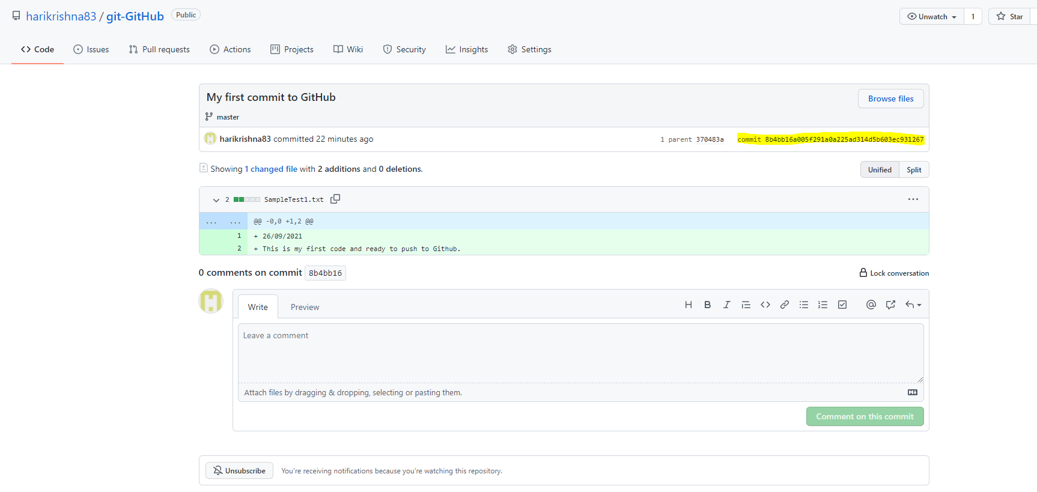

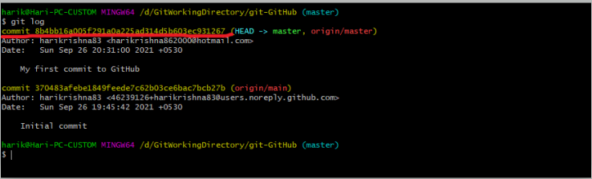

Now I will modify the local file by adding some text to it.

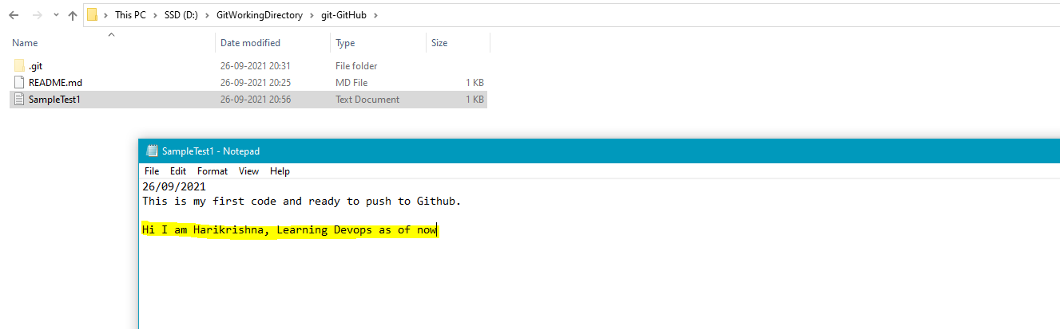

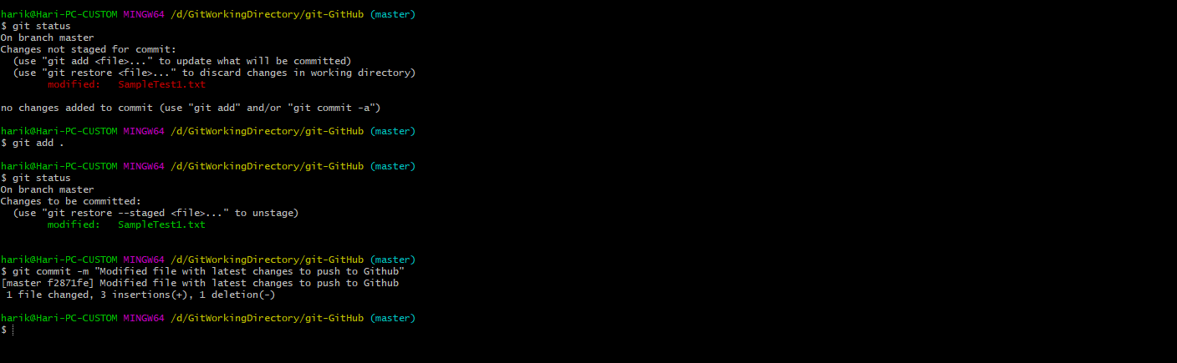

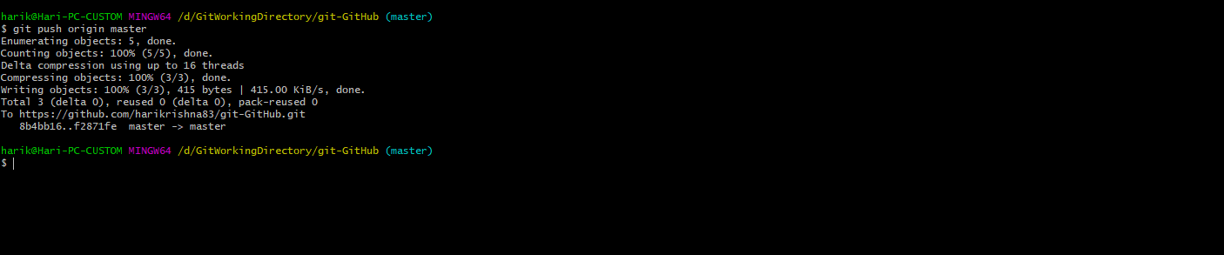

Now refresh the page and see the new comment of commit on GitHub centralized repository.

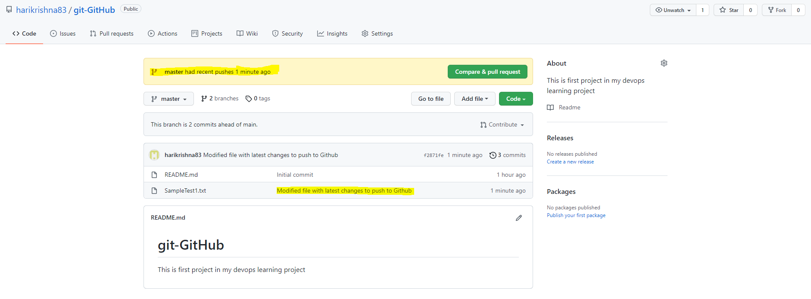

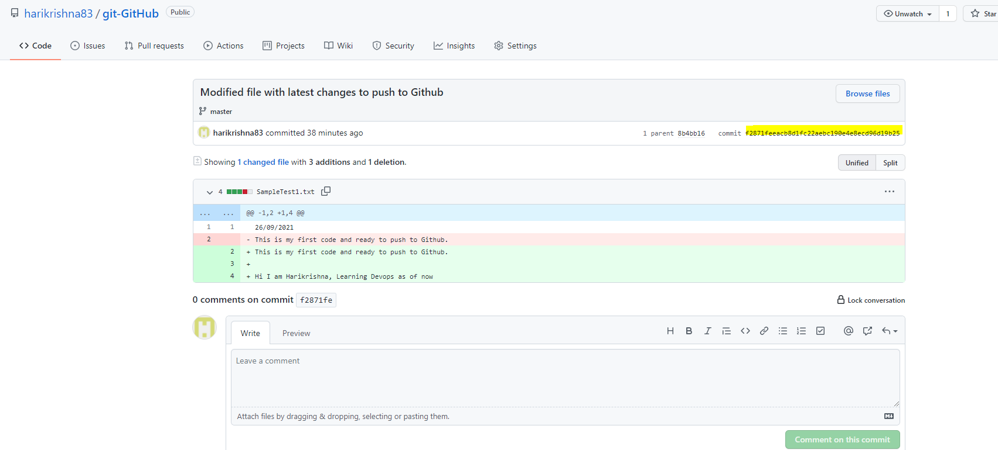

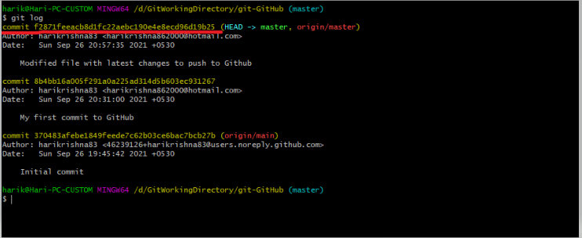

Now I will create a new file on GitHub and will sync the file to from Github to local repository.

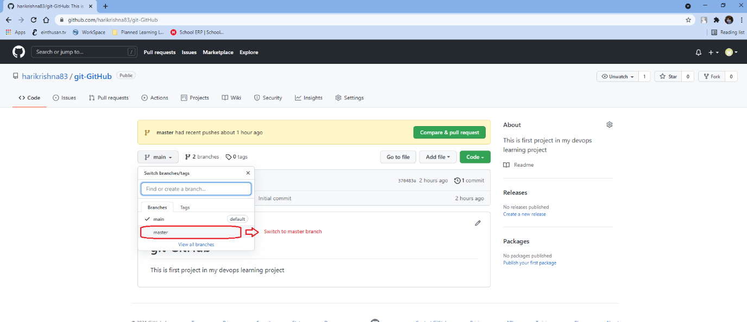

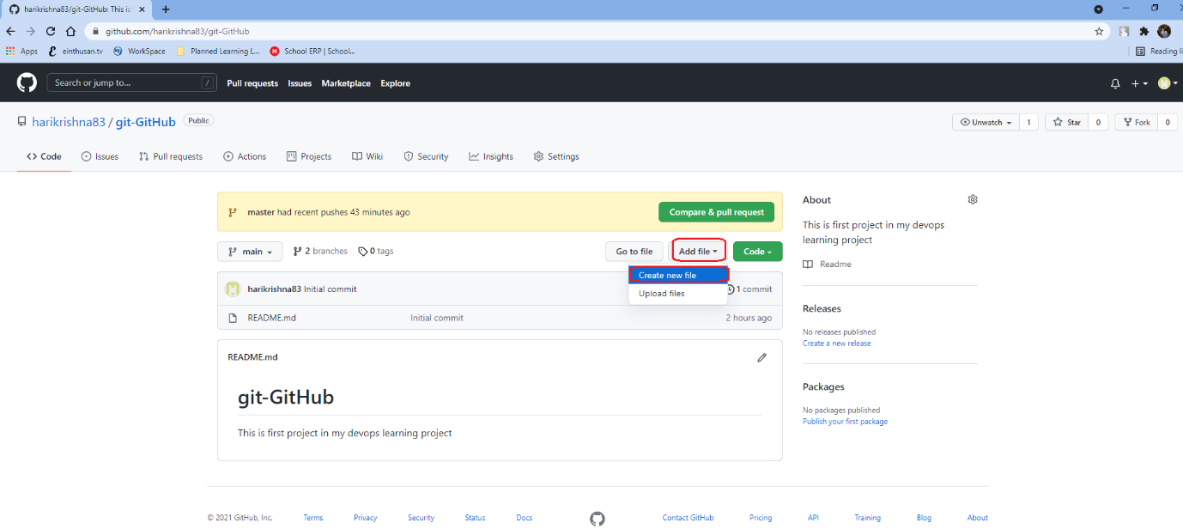

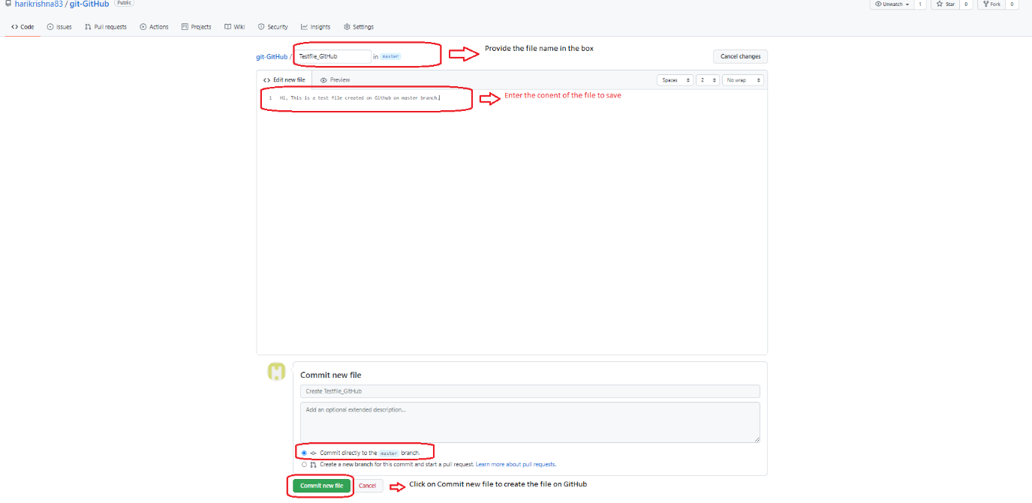

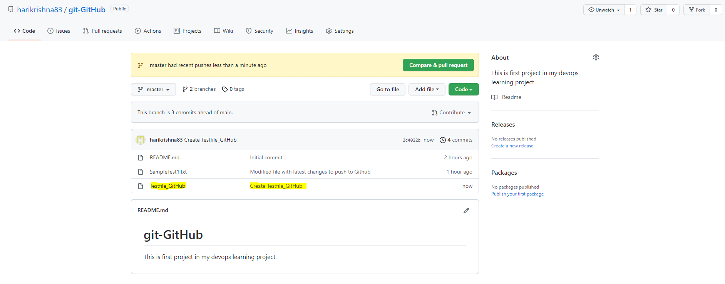

Now I had committed the file in order to get this file to all the other persons they need to pull the changes from centralized repository.

If I want to push the new code to centralized repository, before that you need to always pull the latest changes on the centralized repository.

